# Product recognition on store shelves

Computer Vision 2017/2018

Marco Di Vincenzo

## Introduction

The overall task for this project is to develop a system capable of, given a set of product models, recognizing them in store shelves pictures. This system could be used to help visually impaired people browsing groceries or to automatically detect low in stock or misplaced products.

In order to keep complexity down, we are only considering cereal packages since their characteristic traits are all in the flat front side.

## Goals

This system, given a picture of a shelf, must output for each recognized model their number of instances and for each instance their position and detected scale. The project will be divided in two main steps (plus one final challenge), of increasing complexity.

The first goal to reach is to successfully recognize models assuming only one instance is present at most, while the second one consists in recognizing an arbitrary number of instances. More precisely, the problem statement suggests to use local invariant features to accomplish the first step and the generalized Hough transform (in conjunction with local invariant features) to accomplish the second. Since no indication about the final challenge is provided, various approaches were tried but most of the focus went on the Hough transform.

No explicit real-time requirement is stated, so, throughout the whole project, precision has been preferred over speed, even though an effort has been made to keep everything as efficient as possible.

## Setup

The project has been developed leveraging on the power of the OpenCV 3 library, and it has been written in C++ (standard 14). All of the code (except for the test images) is available at the author’s GitHub profile (<https://github.com/euneirophrenia/CVProjectWork>).

The images (models and test scenes) to work with were provided beforehand and consist of 27 models and 15 test scenes.

Every experiment has been carried out on a MacBook Pro 2013, 8 GB di RAM, 2.4 GHz i7.

In the following, we will see some time measurements but those are relative to the before-mentioned architecture and may vary a bit on other systems, depending on the hardware.

## Problem Analysis

Other than the explicit requirements stated in the problem description, there are other things to care about.

First of all, the models provided are acquired in a very heterogeneous way: there are some with a very high resolution (e.g. 1005 x 1500) and some with a very low resolution (e.g. 161 x 238). Moreover, there are many models that are very similar to each other since they are only flavor variations of the same “base” product. In facts, there are also two perfectly identical models (*9.jpg* and *23.jpg*), possibly due to some human mistake during acquisition.

This situation makes it potentially hard to detect some models thus requiring some attention.

The scene images, on the other hand, are a lot more homogeneous (excluding those used in the final challenge, which, of course, is supposed to be challenging). However, they are rather blurry, probably due to the camera used to acquire them, and they present some “distracting elements” such as price tags or other products not included in the models. It is also worthy to notice that sometimes, the models appear in the scene with some slight variation (e.g. cereal boxes with some bonus gift within advertised, while the advertisement is not shown in the model).

These problems call for a *preprocessing* step in which we can try to solve (or at least to ease) some of these hardships. Since the models are a given, we can ideally preprocess them once, “offline”, and store the results for later usage. This means that we can ideally preprocess model heavily without impact on the run-time performances. Scenes, instead, even though were given to us just like the models, must probably be considered an input that in the actual system will be acquired at run time, so it is important that their preprocessing is as fast as possible.

All in all, we can derive from these problems the first approximated pipeline that will (hopefully) lead to a solution, as shown in *figure 1*, right here below.

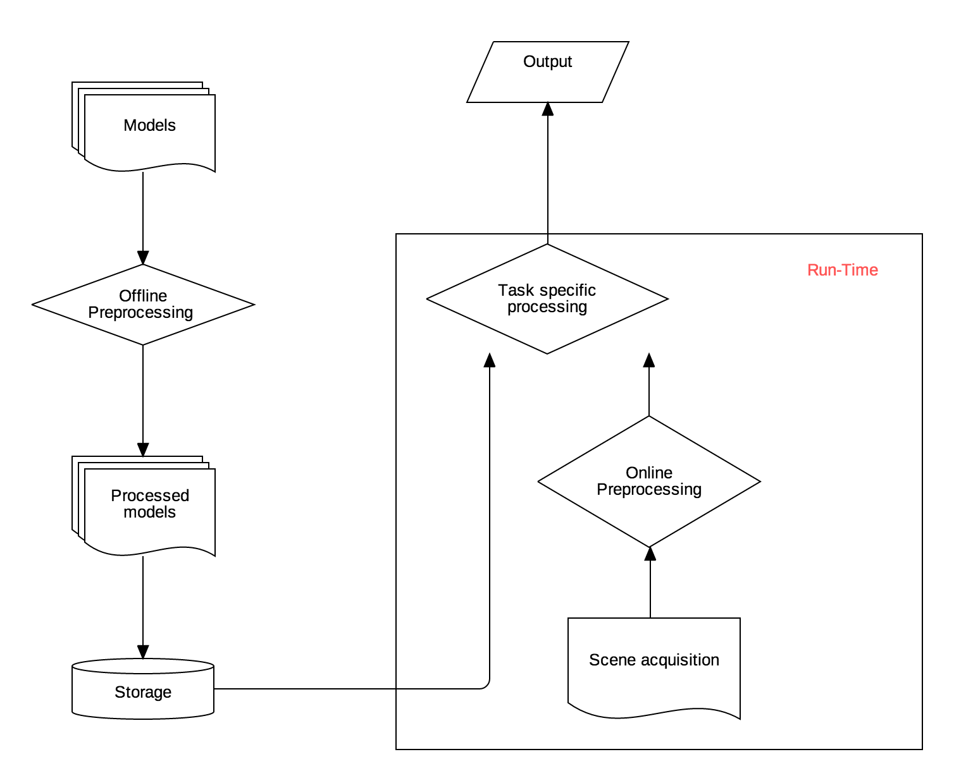

Figure 1 The general Pipeline

More details on the implementation of each steps will be provided soon, following the order of the problem tasks. As a general consideration, the problem text strongly hinted to the generalized Hough transform as a mean to achieve the final toughest goal. For this reason, every consideration has been carried out, tested and tuned with that particular approach in mind.

## Offline preprocessing

During development of the project, this step has been thought about several times.

The only constant idea was to work on gray-scale images; partially because it is more efficient then working on color image but also because color is not a reliable information without proper lighting control.

Since the very beginning, it was clear that it was pointless to have 1000x1500 images when trying to match them in blurry scenes at a lower scale. This would be rather counterproductive since matching high resolution models to low resolution scenes would lead to a lot of spurious matches, potentially hiding the correct (low resolution) model matches. So, the first thought was to scale every model to a common reference size, and to blur them accordingly. Soon enough, “magic numbers” started to appear in the project, representing choices such as the blurring kernel size or the reference scale. While fixed magic numbers may work smoothly in the two basic steps required, they fall *very* short in the final challenge, where models appear at a much lower scale. So, instead of pursuing a way in which we detect by hand one fine tuning of those magic numbers for each step, it has been decided to find a more general way to automatically compute those numbers, so that the overall system could be more consistent and robust with respect to scale changes. Surely, this didn’t prevent the need for some tuning and also ended up leaving an impact on performances, however, as we will discuss soon, both the impact on performances and the amount of tuning needed are extremely low.

### Preprocessing – Resizing the models

The proposed idea is the most obvious one: to scale every model down to the scale of the smallest one, while possibly preserving proportions (every model has in fact a different aspect ratio, it’s best not to alter it). So, the first step was to determine the lowest scale model and this was done (arbitrarily) by finding the model with lowest area (measured as *width x height*).

Before resizing, a Gaussian Filter is applied to denoise the image (and also to prevent artifacts while down-sampling, as signal theory teaches us). The size of the gaussian kernel was tuned by hand and kept rather small in size (3x3), with a σ computed based on the scaling factor (the higher the scale factor, the higher σ), such that if no scaling is involved (i.e. when handling the smallest model) no filtering is involved. Since some models are already at a low resolution, an excessive filtering may destroy important features making it hard to tell apart similar models. The kernel size choice was determined by looking at the effects induced on the performances of the classification task (i.e. on the accuracy), both in the base steps and in the final challenge.

After that, knowing the smallest model, we can choose one dimension (i.e. in this case the *height*) and scale it to match the one of the smallest model, scaling the other dimension (i.e. the *width*) to maintain the original aspect ratio.

However, given the really small size of the smallest model, it was really hard to tell apart similar models, since some useful features (e.g. small writings on the boxes) got lost. So, while keeping the general idea, it was decided to settle for 1.5 times the smallest size. This measure is one of the very few hand-tuned features and was deemed a reasonable tradeoff between the idea explained above and the need to preserve meaningful features: it is not high enough to introduce sensible artifacts (even when scaling up) but high enough to preserve useful details, across the models.

Another idea that has been taken into account was to handle also the model preprocessing at run-time. While this may sound as a bad idea (and in facts it is with respect to execution time), this approach allowed to, in principle, scale the models to roughly match the size at which they appear in the scene (more on this esteem in the following) and this, in turn, allows us to use template matching techniques efficiently rather than local invariant features and the generalized Hough transform. Also, while using the SIFT paradigm to match local invariant features, having images already at the scale in which their most relevant features appear allow us to limit the octave number while still getting good results. However, empirical results show that this is a non-factor probably due to the really good OpenCV implementation of the SIFT paradigm: even limiting the octave number did not produce sensible improvements in computation time. Most probably, the little time saved was lost approximating the model scale in the scene.

Ultimately, the run-time preprocessing of models was deemed a bad idea as also the template matching approach was found incapable of providing better results than using the generalized Hough transform.

### Preprocessing – Image sharpening and de-blurring

Due to the generally low resolution and blurry nature of the models (and the scenes, as well), an image sharpening approach has been tried. However, possibly due to some mistakes in the implementation, this approach did not lead to an improvement in classification precision. Most noticeably, the proposed solution properly classifies every single model in every single test scene (except the final challenge) even without de-blurring, whereas in the final challenge de-blurring introduces some artifacts.

The idea behind the implementation is rather simple: create a blurred image and subtract it from the original image. More precisely, if we did a 1:1 subtraction, the result would be mostly dark, so it is common practice to instead perform a weighted sum with the weights summing up to 1 (e.g. 1.5 for the original image, -0.5 for the blurred version). The results are generally good per se, but at the end of the day they were not able to improve the results and thus they were discarded.



Figure 2.1 A model before de-blurring Figure 2.2 The same model after de-blurring

### Preprocessing – Scale esteem

Albeit not used while preprocessing the models, an esteem of the products’ scale in the scene was deemed useful during the matching phase (we will see why in the following). The key idea is to find the longest vertical line in the scene and use that as an esteem of the height of the models in the scene. This assumption is entirely based on the nature of the scenes, and it was deemed the most robust one. In facts, any rotation of the models around a vertical axis (which are the most likely to happen) will not change the measurement, since rotations don’t alter lines parallel to their axes. On the other hand, rotations around an axis perpendicular to the image plane (i.e. a rotation that would make the model lean towards the camera or the opposite way) would change this measurement. However, we are only considering the *longest* vertical line and even in the unlikely event where all the products were skewed, the space between the shelf’s planes may as well provide a useful vertical line.

In order to detect vertical lines, the OpenCV probabilistic implementation of the Hough transform has been used. More precisely, first we extract edges from the image, using the OpenCV implementation of the Canny’s edge detector and then feed the edges to the probabilistic Hough line transform that will output starting and ending points of the detected lines. A vertical line will be one whose starting and ending *x* coordinate is constant, allowing for an easy computation of the longest line.

Of course, this is something computed at run-time, but only computed once per scene throughout the whole execution, and it’s computed fast enough, as shown in the graph below.



Graph 1 Average execution time in milliseconds for each scene scale approximation

The graph shows the distribution of the average execution time (in milliseconds) computed iterating the esteem for each image 20 times. The average of the averages is highlighted in yellow and it is roughly 70ms.

### Preprocessing – Extracting local invariant features

Many alternative extractors and descriptors were considered. In particular, by experimental results, SIFT descriptors proved to be the most effective in terms of precision. SURF, ORB and RISK were all faster than SIFT but also less precise and for this reason, discarded. It is important to notice that in the first step, given the restrictive hypothesis, all of the above descriptors performed reasonably well. However, as the development pushed towards less constrained steps, SIFT was the clear winner.

Most noticeably, to further improve performance, it has been decided to opt for a variation of the SIFT paradigm: *RootSIFT*. As the name may suggests, it basically consists in extracting a square root from the SIFT descriptors, after a L-1 normalization. Everything else remains totally unchanged. The reason behind, as explained in the proposing paper [1], is that Euclidean distance is not really optimal for comparing histograms (such as the SIFT descriptors) and often leads to inferior performances compared to using other measures (e.g. χ2 or the Hellinger kernel). Basically, this simple correction of the descriptors makes the normal SIFT matching behave as if we were using a better distance measure, improving the matching precision without introducing any significant computational overhead. RootSIFT has been deployed in every step of the process and applied both to the models and to the scene.

### Preprocessing – Similarity detection

As anticipated before, there are many couples of models very similar to each other. However, a formal measurement of this similarity is needed. It seemed reasonable building a “similarity table”, basically a *N x N* table in which each cell (*i, j)* contains a measure of how similar the i-th model is to the j-th model. Since all the project revolves around local invariant features, those have been used to compute those similarity measures as well. More precisely, after the rescaling phase, SIFT-compatible features are extracted from each model and then matched against each other accordingly. The ratio between the number of “good” matches found and the number of key-points was used as similarity measure, where a “good” match is considered such if its distance ratio to the second nearest neighbor is lower than a fixed threshold (as described in Lowe’s paper, who tuned the threshold to 0.7 while 0.65 turned out to work best in this case). Notice that this way the similarity table is not necessarily symmetric, since similar models may have different number of relevant key-points. In practice, for each couple of models (*m1, m2*), the similarity score has been computed as follows:

$$sim\left(m1, m2\right)= \frac{good matches(m1, m2)}{number of keypoints in m1}$$

While the symmetric similarity

$$sim\left(m2, m1\right)= \frac{good matches(m1, m2)}{number of keypoints in m2}$$

Where the matches are obviously computed only once for both the indexes.

This creates a table with each entry ranging between 0 (for completely different models) and 1 (perfectly equal). Given the size of the table, it is not shown immediately here below, but rather in the appendix A (in the last pages). As can be seen, there are some models with well above 20% of their key-points matching (and also, as mentioned before, one couple of completely equal models, possibly due to human error), with the worst offenders reaching almost 39%. While these percentages do not translate directly, they give an idea of the underlying problem: if we matched keeping only the best promising match, we would discard a lot of other equally correct matches, potentially leading to classification as one model instead of the other one. Thus, later on in the process, this table will be used to improve the matching logic: for “easy to tell” models, a faster approach will be used, while for “hard to tell” models a more conservative (and thus slower) approach must be used. For this purpose, in the following, “hard models” will be the ones that have at least one other model with which they scored a “high enough” similarity score, and “easy models” will be the others. An arbitrary (and rather conservative) threshold has been set to 0.1. While higher values might be used to achieve higher efficiency, a conservative threshold was preferred since no explicit time constraint were expressed.

This is by far the heaviest part of the preprocessing, since it takes a lot of time to extract all the key-points, compute features and perform all the $\frac{N x (N-1)}{2}$ matches, but we are assuming to be able to perform these operations once and for all “offline”. Moreover, given the previous (qualitative) definition of “easy” and “hard” models, we don’t actually need to compute the full table: for a given model it is enough to find one other similar model to label it “hard”, no need to test any further after that.

## Step A – Multiple Product Detection

As anticipated before, this step’s goal is to deploy local invariant features to recognize different products in the same scene, under the hypothesis that one instance at most is present for each product. Once local invariant features are extracted, this is quite straightforwardly solved by using OpenCV built-in matching functions. Most noticeably, there are two ways to perform matches according to OpenCV documentation: between a single model and a single scene or between one model and multiple scenes. Clearly, there is no implicit knowledge within the matching functions about what a model is nor what a scene is, so the second approach can be easily used to match between one scene and multiple models. However, in this case, a little attention must be paid. As a general rule, in the project, good matches have been selected according to the *second nearest neighbor distance ratio* test, as suggested by Lowe, in his famous paper [2]. In this case, given the presence of very similar models, while matching against multiple models at once, it is highly probable for the second nearest neighbor to be rather close. Thus, a simple test between those distances will work only on the so-called “easy models”, while on the “hard models” it would lead to a loss of (potentially) good matches. While this loss is by no means significant if the overall number of matches is high enough (i.e. if the scene has high enough resolution), it becomes really impactful as the scene resolution lowers. It is also important to notice that now we are working under the assumption that each model figures at most *once* in a given scene. This makes it easier to tell apart similar models if they both appear in the same scene, since their matches will not hide each other, even when matching multiple models at once.

For instance, consider the following result obtained by matching multiple models at once (ignoring similarity):

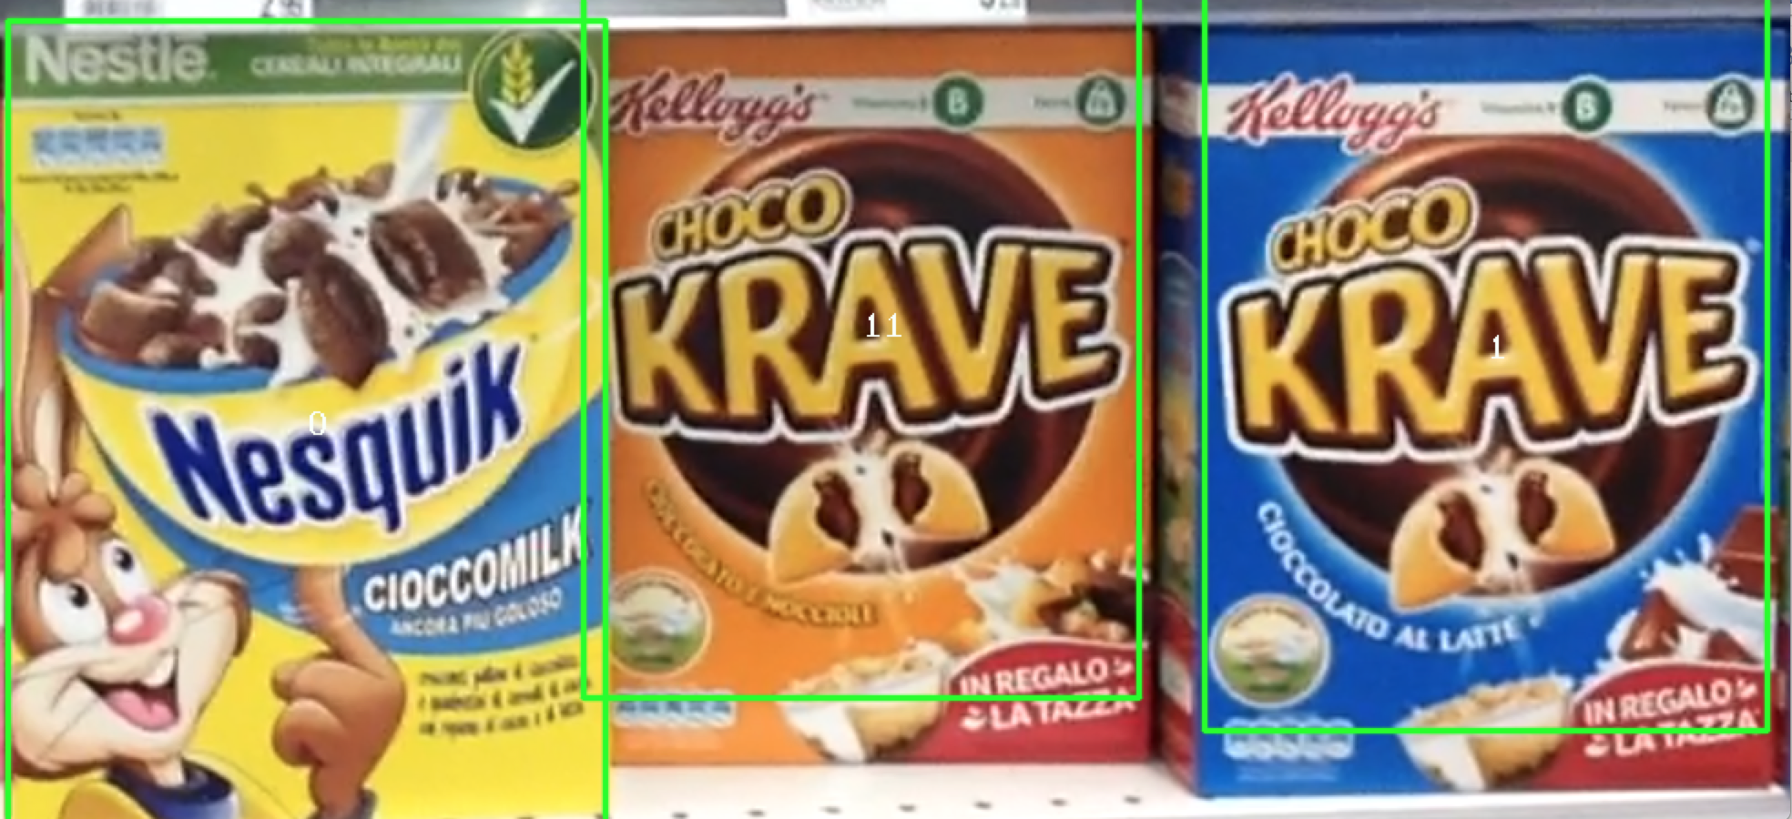

Figure 3 Scene e3 after matching multiple models at once

In this case, even if the central model and the right-most model are very similar (and actually, for several reasons, are the hardest couple to tell apart), even matching several models at once does not lead to a loss of classification accuracy, since matches won’t hide each other. On the other hand, if only one of those two was in the scene, matches would have hidden one the other, as in this example:

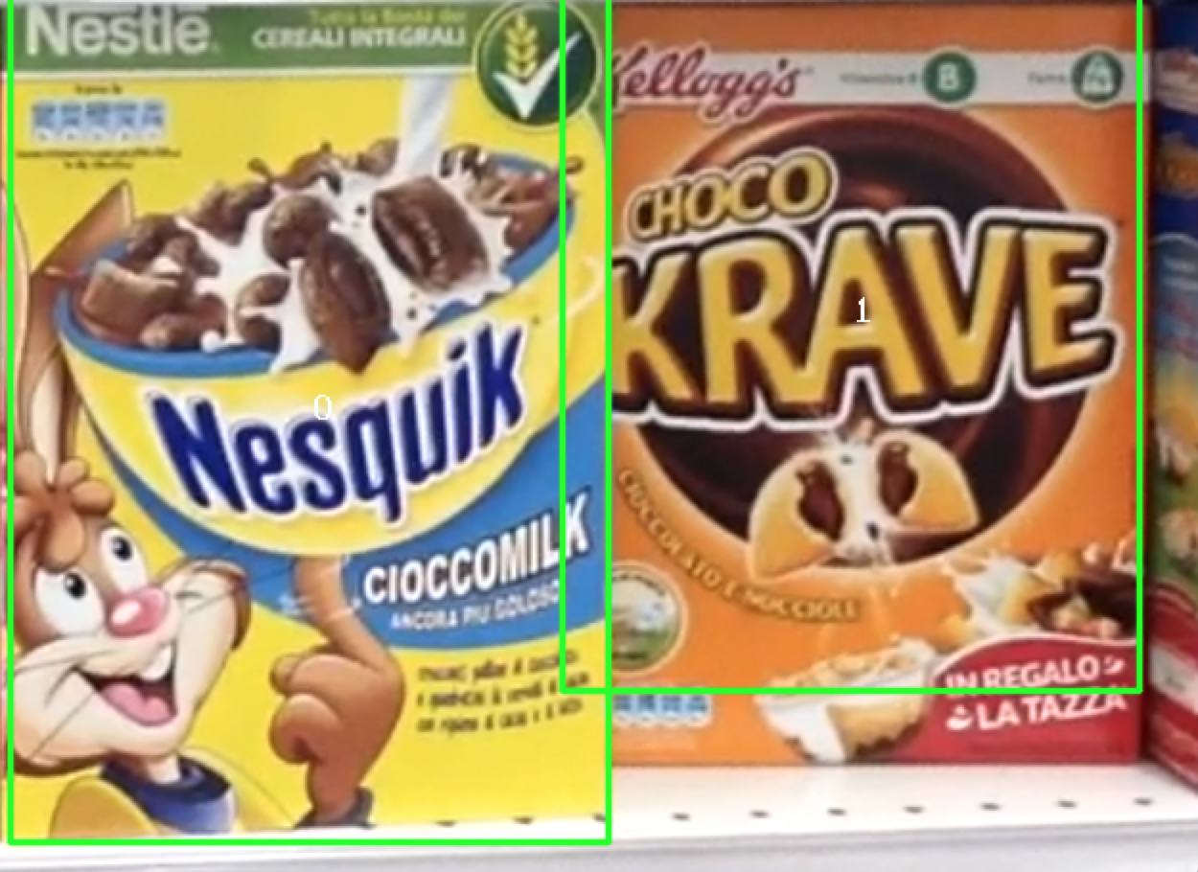

Figure 4 Scene e1 after classifying with multiple models at once

As we can observe, the (now) right-most model (*model 11*) has been erroneously classified as *model 1*. This happens for several reasons. First of all, it is important to notice that there is an extra element in the model as it is in the scene compared to as it was provided (the extra advertisement on the bottom-right corner), plus the distinctive writing (“cioccolato e nocciole”) being moved on the opposite side (to accommodate room for the advertisement), coincidentally ending up exactly in the same place where *model 1* has its own writing. All of these things, combined with the fact that *model 11* came at one of the lowest resolution (while *model 1* at one of the highest) make the matches of model *1* overlap with many of those of model *11*. At this point, some algorithms involving colors were taken into consideration, however color was deemed too unreliable, and subject to occlusions, variations of the models and variations of lighting. Instead, it has been decided to use the similarity information to refine the above discussed method and to split the problem in two: the detection of “easy models” (by matching multiple models at once) and the detection of “hard models” by matching one model at a time.

In particular, once all the matches are collected for each “hard” model, a way to solve conflicts has been devised. First of all, only the models with a reasonably high number of matches is kept. After that, a position is computed for each of those models and for the models *close* to each other (whose distance is below a threshold) only the one with the highest number of matches is kept.

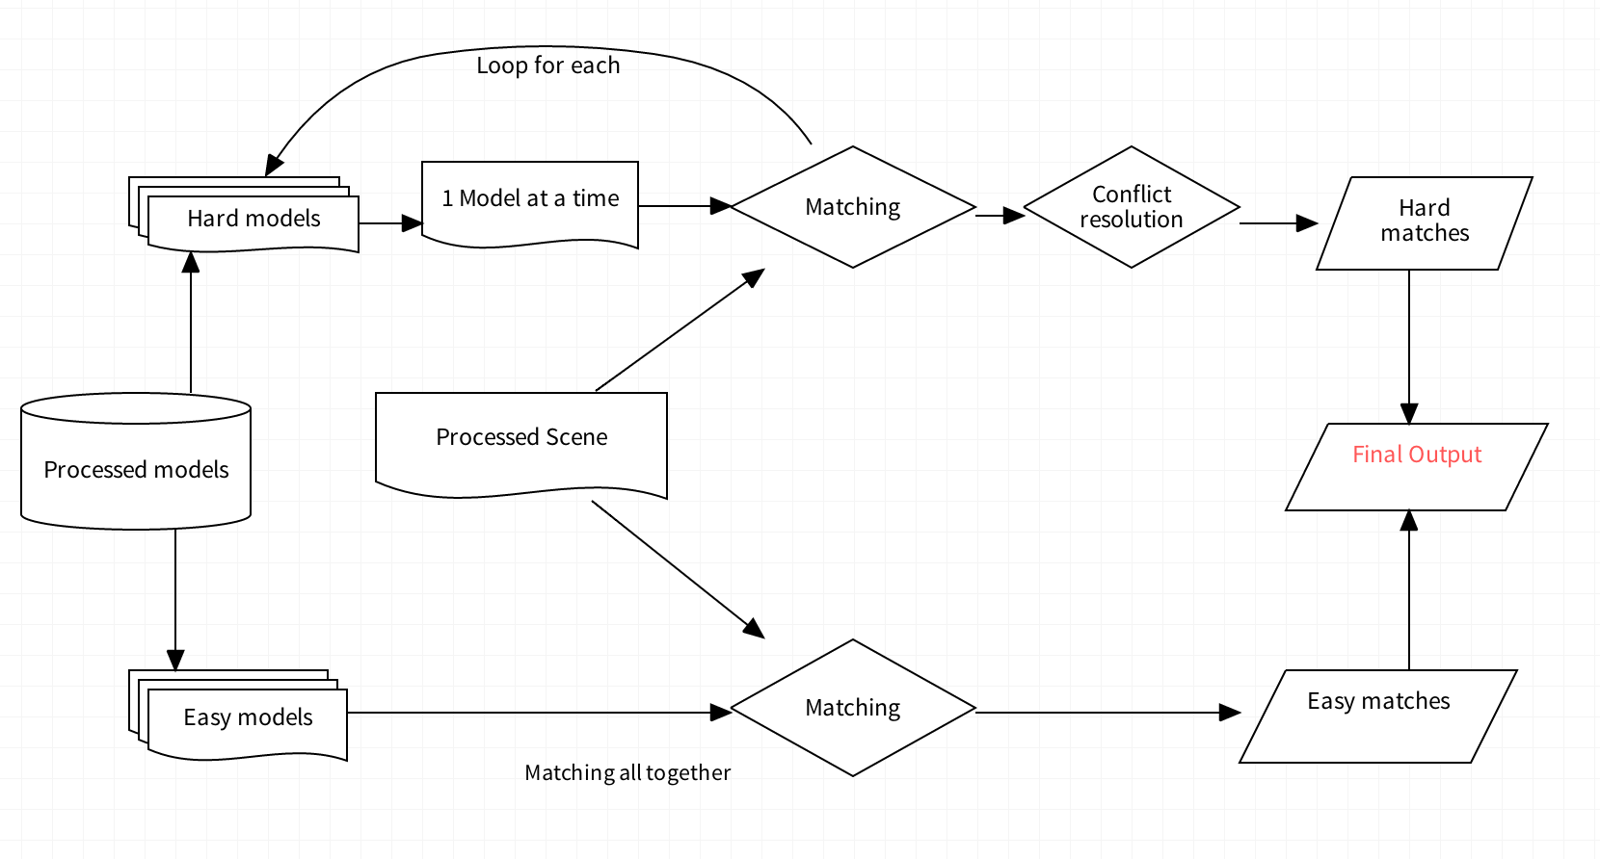

Figure 5 The overall combined approach

This approach to resolve conflict is somewhat similar to (and actually inspired by) the generalized Hough transform. In facts, each match “votes” for the presence of its corresponding model and only the most voted models are kept.

As we can see, this time there’s no trouble telling apart models, no matter the scene.

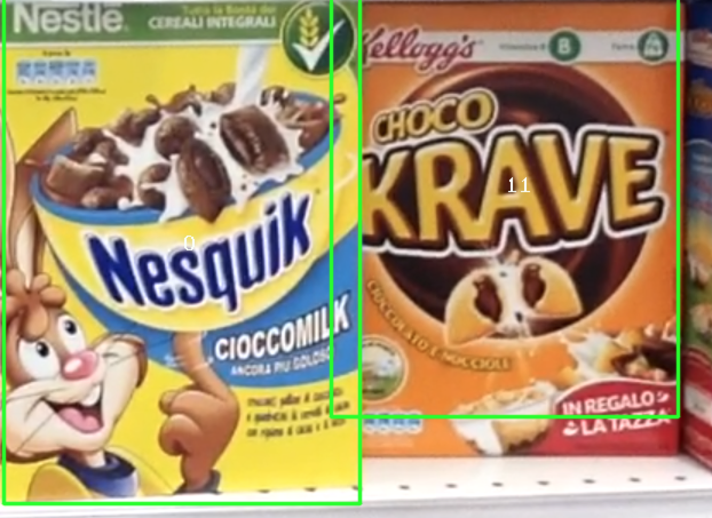

Figure 6 Scene e1 properly classified

In terms of performance, matching multiple models at once is several times faster than matching one at a time. Clearly there are less function calls and context switches, but the main point is that matching multiple models returns less matches (for the reasons discussed before, some “otherwise good” matches shadow each other) and this lifts a lot of weight from all the following computation. In facts, if only the heavy “1-at-a-time” matching version was used, the execution time averages around 2 seconds per scene. Instead, while using a combination of the two approaches, the average computation time drops by half, as shown in the graph below, while still giving perfect results. The blue values are the one obtained matching easy models all at once and then matching hard models one by one solving conflicts while the orange one only applies the “one by one” approach for all the models.



Graph 2 Comparison of 1-by-1 approach and the compound approach (time expressed in seconds)

The test was limited to only these five scenes because this approach does not work “as is” with multiple instances of an object (which is the case of the other scenes), for which a complete version of the generalized Hough transform will be used. Results for the “fast-only” (matching all the models at once) version are not showed since it does not always produce correct results, while the other two do.

Notice that performances are heavily affected by the definition of “hard models” (i.e. by the choice of the similarity threshold: the higher the threshold, the less hard models there will be, thus leading to improvement in computation time. On the other hand, too high of a threshold may lead to a loss of accuracy.

In appendix B, all the final experimental results (i.e. the classified scenes) are reported in detail.

## Step B – Multiple Instances Detection

Now we must lift the single instance hypothesis. This carries some consequences: now matches can also be diluted across the various instances. If we matched from a model to the scene, always using the second nearest neighbor rule as before, we would have every instance of the model compete against each other. Luckily enough, this can be solved easily enough by “inverting” the direction of the match (i.e. matching from the scene to the model).

As the problem text hinted, the generalized Hough transform has been deployed to handle the detection of multiple instances. More precisely, for each model image an “Hough model” has been extracted during the preprocessing phase. Each Hough model consists of a look-up table (i.e. an array)…………

## Step C – Whole Shelf Challenge

## Implementation details and overall optimizations

## Possible improvements and future developments

## Appendix A – Similarity table

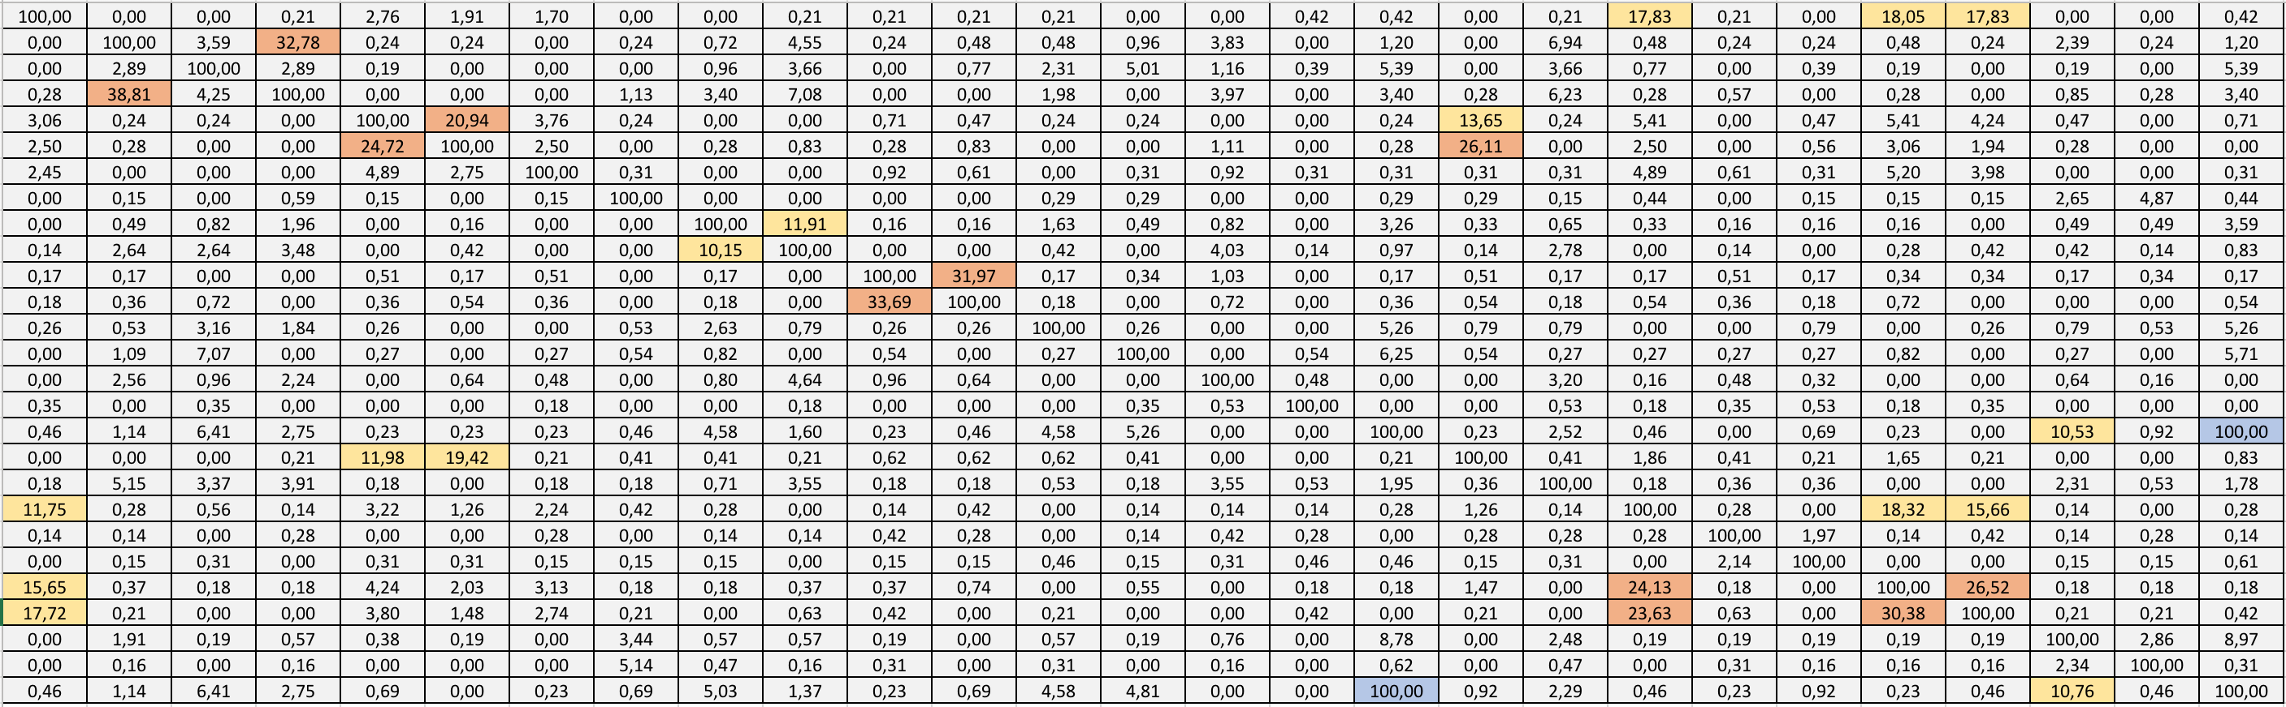

Table 1 Similarity table, scaled by 100 to represent a percentage

## Appendix B – Step A full classification outputs

## Bibliography

[1] *Three things everyone should know to improve object retrieval*, Relja Arandjelovi´c, Andrew Zisserman, 2012

[2] *Distinctive Image Features from Scale-Invariant Keypoints*, David G. Lowe, 2004